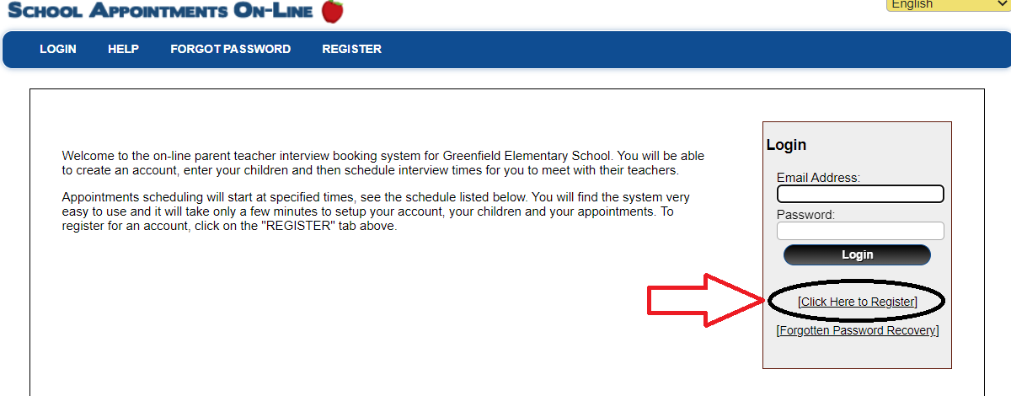

Once you’ve created your account you will be asked to add a student:
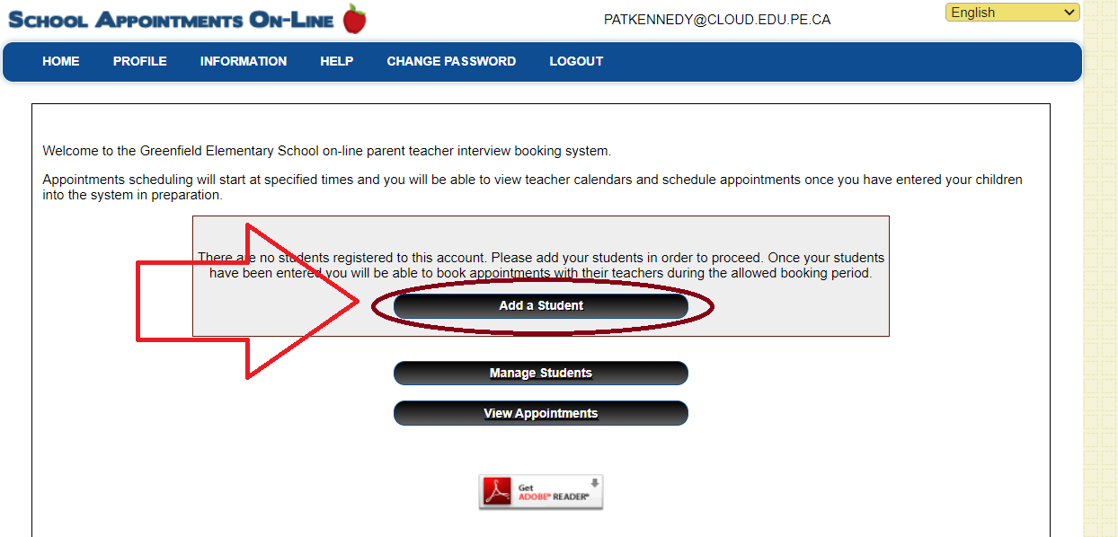

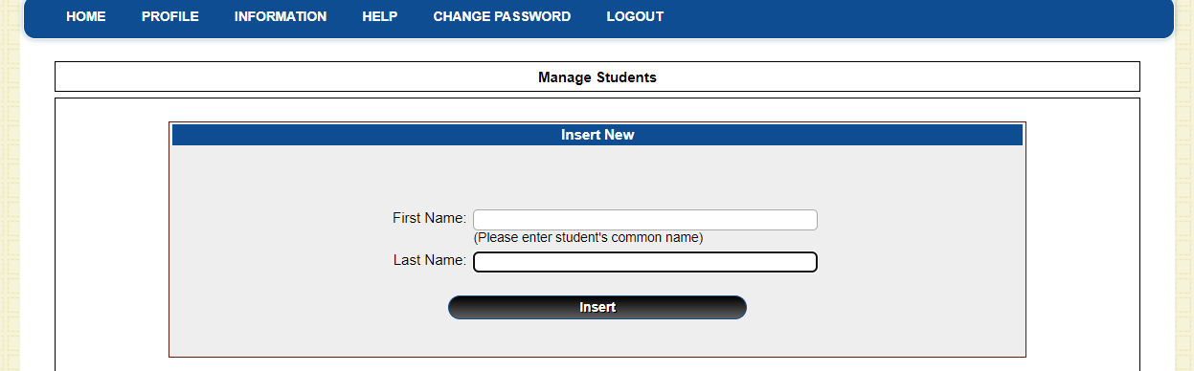

Once you have added your student click the schedule icon on the far right side of their name:
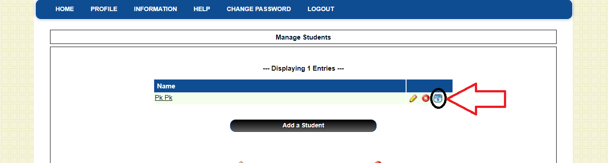
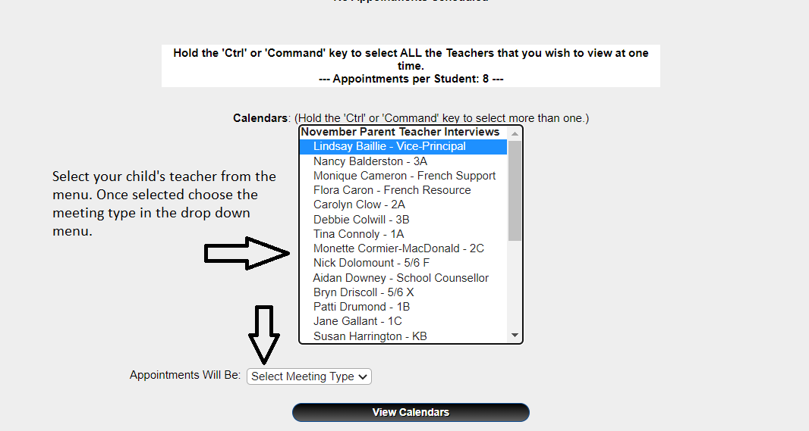
Once selected click the view calendar button.
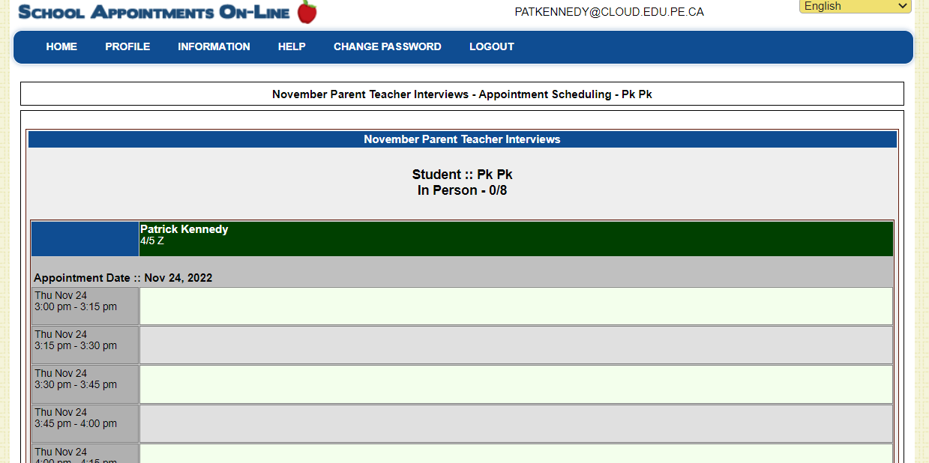

Select your time. Repeat the process for any additional teachers your child may have or if you have more than one child attending Greenfield.

